James Leichty – KDASC Webmaster
KDASC Website: www.kdasc.org (our new website URL!)

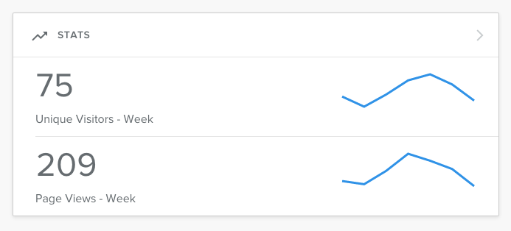
Since the purchase of the new KDASC URL (www.kdasc.org), the web traffic to our site has grown exponentially! This means that everyday, more and more people are seeing who we are and what our organization is about. In my opinion, this upgrade has allowed the KDASC to expand beyond its horizons, reaching those that we may not have before. Below you will see the statistics that show our current standings:

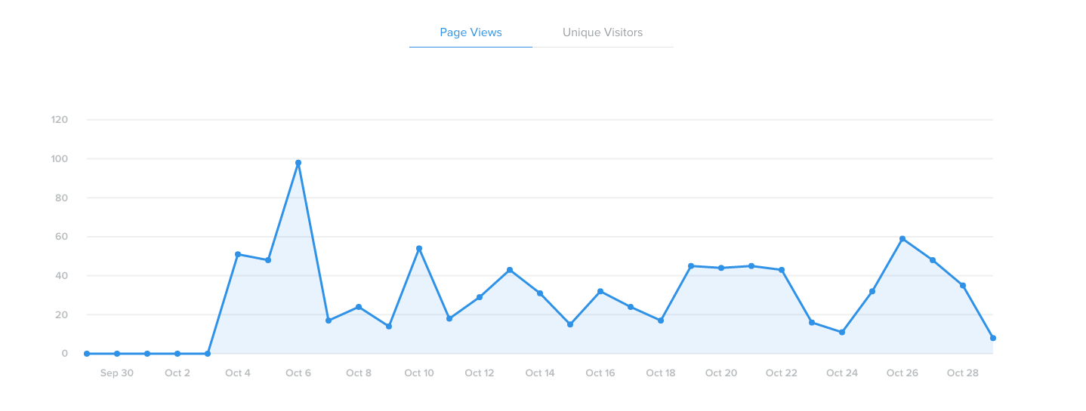

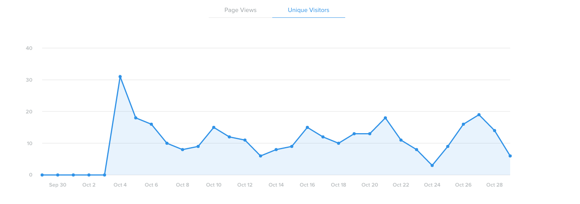

The website is currently up to date and will again be updated for the month of November in the coming days. Please let me know if there is anything you would like announced on social media or through our website and I will make sure to put it up.

Thanks,

James Leichty
KDASC Webmaster

