President
Ali Brann
Unity
alisynmykal12@yahoo.com

Vice-President
Lauren Ovca
Tuscola
lauren.ovca@gmail.com

Secretary
Olivia Christy
Tuscola
liv.christy96@gmail.com

Treasurer
Larissa Moses
Shiloh
mo6367@cell1net.net

State Liaison
Austin Dean
Atwood-Hammond
puff.dean@gmail.com

Historian
Allison Hemmer
Tuscola
arhemmer7@gmiail.com

Virtual Historian
Kaci Spry
sprygirl_94@yahoo.com

Convention Secretary
Emily Williams
Mahomet-Seymour
emily.williams197@gmail.com

Webmaster
Nick Appleby
Atwood-Hammond
jackson735@yahoo.com

Are You Ready for a GREAT Year?
The KDASC has some exciting things planned for this school year! We have everything from games to service projects. Our officers have been looking for ways to improve our district to make it the best that it can possibly be. If anyone has any great ideas the officers would be delighted to hear them.
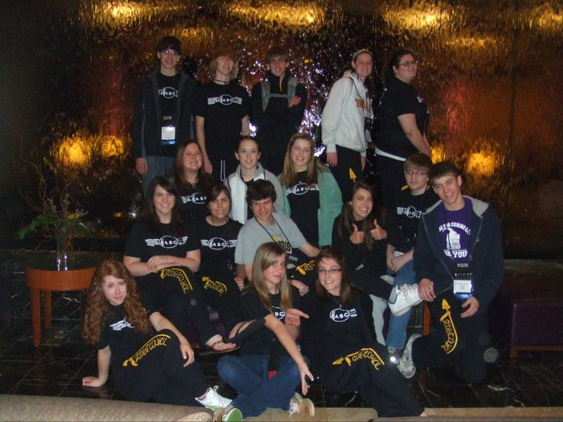
Let’s Increase Our Membership This Year!
One of our big goals this year is to increase our district membership. This means inviting other schools in our district to participate in events, or just simply increasing participation in your school. The more people that get involved, the better the year!

Kickapoo Cares
We will be continuing our service projects this year with Kickapoo cares.
The organizations we donated to last year were always extremely excited to see our KDASC members walk through their doors with bags full of items. The smiles on their faces are absolutely priceless.
As in past years, we are continuing the prize for most items per person per school. The school to bring the most items per person will get to eat first at the event. For an easy way to get participation at your school, just suggest everyone bring at least one item with them to the event!
At the end of the year, we will look at the school who brought the most per person overall, and that school will get to eat first at district convention!
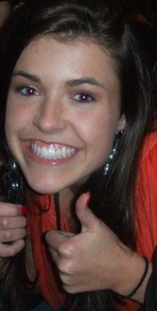
Don’t Forget
to
Check Out
the KDASC District Website, and
Feed
the Turtles!

List of Events
Fall Picnic
Cunningham Children’s Home
Halloween Dance
Center for Women and Children in Transition
Fall Retreat
Crisis Nursery
Winter Retreat
Beth’s Place
Hospitality Night
Times Center

State Convention: The New Road To Leadership

Last year’s Student Council State Convention was a huge success! It was busy and energetic convention that brought together old friends and formed new relationships. 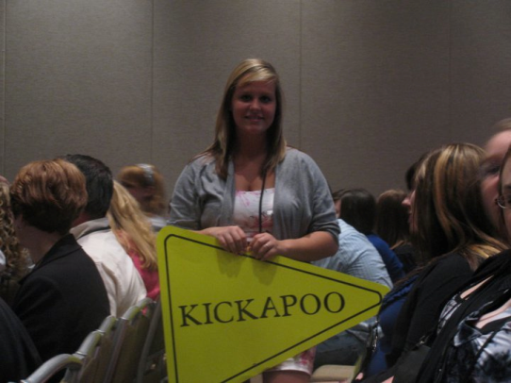
The days were filled with motivational speakers, discussion groups, and round table discussions that sparked creativity in every person. There were tons of opportunities for students to learn new leadership styles and ideas to bring back to their local council.
As for the evenings, each night had a different scheduled activity. They included a hypnotist, a dance, a banquet, and some free time to mix and mingle with people from all over the state.
The banquet was very touching this year. As the old board members said goodbye to the state and their office, several tears began to fall. The old board was sad to be leaving, but they were leaving the state in good hands.
The new board is ready to start the year off on the right foot. They are working on statewide service projects and retreats to make them better in every possible way. 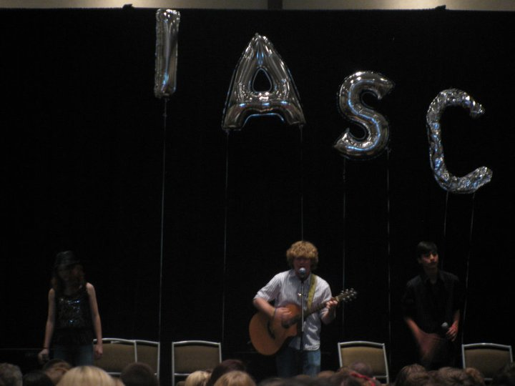
Convention ended on a bittersweet note as always. New friends said goodbye and made plans to meet up at the next state event. For anyone who has not attended state convention, it is a truly wonderful experience that you will never forget.

Games!!!
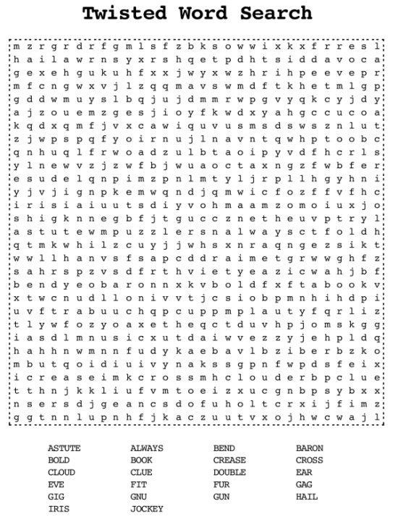
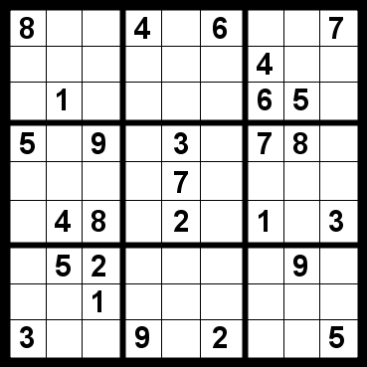

Hope to see everyone at the Halloween Dance!

